SGH Warsaw School of Economics

THE STRATEGY OF SOCIAL RESPONSIBILITY OF THE SGH WARSAW SCHOOL OF ECONOMICS

Warsaw, 24 May 2021

Foreword by the Rector of the SGH Warsaw School of Economics

As the leading Polish economic university, the SGH Warsaw School of Economics attaches great importance to social responsibility and sustainable development: both in its educational and scientific activities. Engagement in this realm is supplemented by the efforts for the sake of responsible operation of the SGH Warsaw School of Economics as an enterprise.
The employees’ and students’ growing interest in social responsibility is, on the one hand, a consequence of more and more common awareness of contemporary challenges and on the other it is a response to the pro-active stance of the School in this respect. Strategic activities are aimed at including the sustainable development to a fuller degree both in our didactic mission and scientific activities, as well as in social type projects, supporting the local community and assisting in resolution of global type problems, including environmental problems.
It is worth emphasising that the SGH Warsaw School of Economics is a signatory of the University Social Responsibility Declaration which is intended at setting up, together with other Polish universities, an eco-system conducive to the formation of stances and promoting the idea of sustainable development and social responsibility in all areas of the university's operation.
The social responsibility strategy of the SGH Warsaw School of Economics is one of key cross-cut strategies scheduled for implementation in years 2022-2032; its premises are making strong references to the development strategy of the SGH Warsaw School of Economics. Adoption of the strategy by the School indicates that applying top social responsibility standards in all areas of operation of the SGH Warsaw School of Economics, namely science, teaching, relations with the external environment and management, is a development factor of major importance.

Rector of SGH Warsaw School of Economics
Professor Piotr Wachowiak Ph.D.

- Mission, vision, values and motto

Mission
The SGH Warsaw School of Economics is an innovative economic university developing creative intellectual potential and educating leaders in response to the challenges of the future. It is a globally significant centre of scientific research, new ideas and initiatives created by the academic community, graduates, as well as the representatives of business, social organisations and public administration. The SGH Warsaw School of Economics, as an independent and socially sensitive university, shapes civic and ethical engagement by its teaching, research and opinion-forming activity.

Vision
The SGH Warsaw School of Economics will be the leading, opinion-forming European University joining the best features of an economic university and a business school. By deriving from the academic tradition and the newest achievements of science, the open and active Community of the University will integrate interdisciplinary research conducted in the international environment with economic practice and shape leaders who are socially responsible and able to take up challenges of the future.

Values
Truth – honest and brave conduct in compliance with the facts and objectivism.
Professionalism – understood as responsible activity based on continuous development, high quality.
Honesty – means transparent and just conduct in compliance with the principles universally adopted in the society.
Respect – understood as welcoming, dignified and equal treatment, as well as confidentiality.
Cooperation – establishing good relations based on trust and mutual support to create community.

Motto
We educate and conduct research in an ethical manner by means of a dialogue out of concern for the balanced development of the society and economy.

- Stakeholders
Key stakeholders of the SGH Warsaw School of Economics include:
- female and male employees;
- female and male students;
- female and male doctoral students;
- female and male course participants;
- suppliers;
- the SGH Warsaw School of Economics’ Partner Club;
- female and male candidates;
- the ministry relevant for science and higher education and other regulators;
- trade unions;
- accreditation and control institutions;
- media;
- partner universities;
- universities;
- female and male graduates;
- enterprises;
- youth and teachers of elementary schools and secondary schools;
- non-governmental organisations;
- government and local government administration;
- local community;
- society.

Matrix of the SGH Warsaw School of Economics’ stakeholders
The matrix of the SGH Warsaw School of Economics determines the level of stakeholders’ impact on the University and the level of the University’s impact on stakeholders.
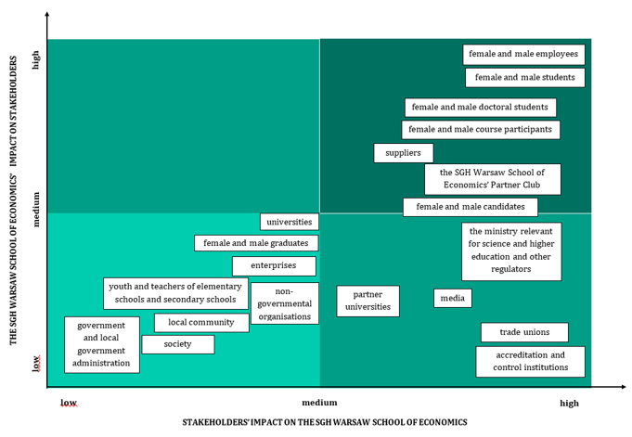

- Strategic goals referring to the Sustainable Development Goals of the UN

The Strategy of Social Responsibility of the SGH Warsaw School of Economics refers to the guidelines of the University’s development strategy for 2022 – 2032 adopted by the Resolution of the Senate of the SGH Warsaw School of Economics no. 87 of 28 April 2021. The SGH Warsaw School of Economics’ development strategy covers the following strategic areas:
- science;
- education;
- relations with the environment;
- management of the University.

Through the implementation of the strategy of social responsibility of the University the SGH Warsaw School of Economics supports the sustainable development of the society and economy. The SGH Warsaw School of Economics as the socially responsible University initiates activities that contribute to the achievement of the global goals of the UN and, in particular, the following: no. 4 – quality education, no. 7 – affordable and clean energy, no. 8 – decent work and economic growth, no. 10 – reduced inequalities, no. 12 – responsible consumption and production and no. 17 – partnerships for the goals.

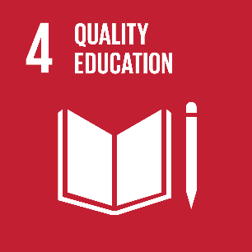 | 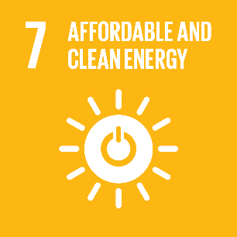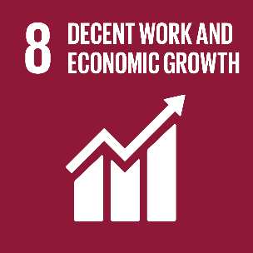
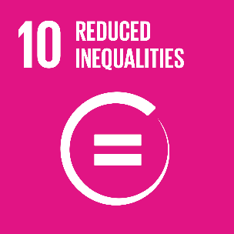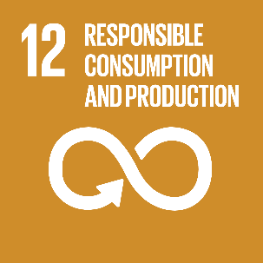 |  | 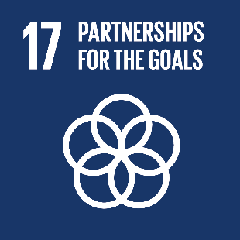

Global UN responsibilities will be favoured by the implementation of strategic and operating goals:

STRATEGIC GOAL 1
Conducting dialogue with stakeholders and increasing their engagement
Operating goal 1
Conducting a continuous dialogue with employees and increasing their engagement in reinforcing the University community.
Operating goal 2
Conducting a continuous dialogue with students, doctoral students, course participants and representatives of the School’s environment and increasing their engagement.
Operating goal 3
Ensuring good work and development conditions for employees and persons learning at the SGH Warsaw School of Economics.
Operating goal 4
Ensuring good education/cooperation conditions for students, doctoral students, course participants and representatives of the School’s environment.
Operating goal 5
Taking the perspective of students, doctoral students, course participants and the School’s environment into account in research and publications.
Operating goal 6
Taking the perspective of students, doctoral students, course participants and the School’s environment into account in education.

STRATEGIC GOAL 2
Increasing the University’s contribution to the benefit of the sustainable development
Operating goal 7
Environmental management in the University’s activity.
Operating goal 8
Taking social and environmental issues into consideration in research and publications.
Operating goal 9
Taking the topic of contemporary social and environmental challenges into consideration in education.

STRATEGIC GOAL 3
Providing education and conducting scientific research oriented to the needs of an open economy – both in terms of teaching and scientific activity of the organisation, as well as in terms of the curricula
Operating goal 10
Promoting research and work on publications.
Operating goal 11
Promoting results of research and publications.
Operating goal 12
Adjusting education to various needs and capabilities of learning persons.
Operating goal 13
Providing education at each stage of life (Open University of the SGH Warsaw School of Economics supporting life-long learning)
4. Operating goals in the area of Science

Operating goal 5

Taking the perspective of students, doctoral students, course participants and the School’s environment into account in research and publications.

In the process of designing research or, more broadly speaking, research and publication projects the SGH Warsaw School of Education takes into account the needs of internal and external stakeholders of the University by:
- using research and publications in teaching work;
- sharing the research results with the SGH Warsaw School of Economics’ stakeholders and using these results in the advisory, education and social activity, including support for government and local government institutions;
- creating an advisory body (council) composed of the representatives of various groups of the SGH Warsaw School of Economics’ stakeholders, assessing the usefulness and the impact of the research and publications on their environment (setting up e.g. an award of the aforementioned council in this scope or compiling a list of publications and research projects serving the environment of the SGH Warsaw School of Economics’ stakeholders to the highest extent).

Measures
- The number of research and publications which refer to the surveys on stakeholders’ expectations.

Operating goal 8

Taking social and environmental issues into consideration in research and publications.

The SGH Warsaw School of Economics supports research and compilation of scientific publications including environmental and social issues by:
- supporting research projects and publications taking into consideration the perspective of the SGH Warsaw School of Economics’ stakeholders;
- supporting research projects and publications taking into consideration the issues of social responsibility and sustainable development;
- promoting the principles of analysis of research projects at the moment of assessment thereof before the start of the project or before application for funds (especially in the case of co-financing or financing by the SGH Warsaw School of Economics).

Measures
- The share of research and publications concerning social and environmental issues in all research and publications of the employees.

Operating goal 10
Supporting research and works on publications
Shaping and supporting in the scientific environment of the SGH Warsaw School of Economics approaches related to social responsibility, sustainable development and environment protection. Raising awareness in the scope of the need to take these issues into consideration in scientific work, especially:
- conducting communication actions indicating the need to take into consideration the aforementioned issues in scientific projects;
- compiling a list of the best practices in this scope;
- supporting and animating efforts of academic employees in the implementation of these issues into the area of research and publications.

Measures
- The number of projects concerning social responsibility and sustainable development implemented by the University.

Operating goal 11

Promoting results of research and publications.

The SGH Warsaw School of Economics conducts activities in the scope of promoting publications and research of employees at the same time indicating the directions of application and social value thereof by:
- promotion of research, results thereof and publications on the national and international arena (with a particular consideration of publications in the open access);
- creating own repository and separating open access.

Measures
- The number of scientific publications of the SGH Warsaw School of Economics’ employees in the open access (including the number of publications in the Cyber Open Repository of the SGH Warsaw School of Economics).

5. Operating goals in the area of Education
Operating goal 6

Taking the perspective of students, doctoral students, course participants and the School’s environment into account in education.

This goal will be implemented by:
- participation of students and doctoral students (represented by Student and Doctoral Student Governments) in works of bodies developing programmes of studies and curricula at the Doctoral School – Councils of Faculties, Senate Curriculum Committee, ad hoc teams;
- participation of students and doctoral students in the assessment of hitherto curricula by the aforementioned bodies by student surveys etc.;
- participation of employees in the works of bodies developing programmes of studies – the Council of Faculties;
- increasing the number of classes taking into consideration students’ activity in the spirit of “student centred learning”.

Measures
- The number of students participating in the works of bodies developing programmes of studies.

Operating goal 9
Taking the topic of contemporary social and environmental challenges into consideration in education.
Shaping students’, doctoral students’ and course participants’ approaches taking into consideration ethical, social and environmental aspects in the professional, scientific and non-professional activity (at the local, national and global level) primarily by:
- taking into consideration classes devoted to ethics, sustainable development, social responsibility in programmes of studies and post-graduate studies;
- taking into consideration the perspective of social responsibility and sustainable development in selected subjects, modules and classes e.g. by choosing examples;
- including students in research and education initiatives;
- supporting and animating social activity, student voluntary work;
- promoting among doctoral students (candidates for the Doctoral School) the research concerning the topic of social responsibility and sustainable development.

Measures
- The number of subjects and education projects that take the subject matters concerning ethics, sustainable development, social responsibility into account in the curriculum.

Operating goal 12
Adjusting education to various needs and capabilities of learning persons.
Openness to the needs of students, doctoral students, course participants (including foreigners) of unusual needs (with the preservation of qualitative requirements). This goal will be implemented by:
- developing flexible forms of classes, compensatory classes, tutoring, adaptation classes for foreigners (with regard to C1D3);
- support from administrative units (implementation of relevant procedures);
- preparation (training) for working with such persons provided to the teaching and administration staff (among others appointment of the Centre for Development of Teaching Competences).

Measures
- Percentage of trained teaching and administration staff with regard to atypical needs of students, doctoral students and course participants.
- The number and characteristics of initiatives aimed at supporting persons of atypical needs.

Operating goal 13
Providing education at each stage of life (activation of the Open University of the SGH Warsaw School of Economics supporting life-long learning)

Developing by the SGH Warsaw School of Economics (also with external partners) educational offer other than studies and postgraduate studies targeted at the local community and not only, especially:
- developing activity within EUD, AMD (with classes for parents), academic classes;
- University of the Third Age;
- popularisation (including among the English speaking recipients) of scientific knowledge by promoting results of the research conducted by the SGH Warsaw School of Economics’ scientists; development of open lectures, seminars etc. (including online forms).

Measures
- The number of initiatives (and the number of participants thereof) targeted at others (than students and postgraduate studies participants) learning persons divided into forms and groups of participants.

6. Operating goals in the area of Relations with the environment – responsibility towards stakeholders

Operating goal 2
Conducting a continuous dialogue with students, doctoral students, course participants and representatives of the School’s environment and increasing their engagement.
This goal requires:
- identification of the needs and requirements, as well as collecting feedback from students, doctoral students and course participants, as well as representatives of the School’s environment (conducting at least once an academic year dialogue sessions with particular groups of stakeholders);
- supporting various forms of participation of students, doctoral students and representatives of the environment in the SGH Warsaw School of Economics’ life by:
- developing a participatory platform allowing various groups of stakeholders to co-participate in conducting education activity,
- developing a programme allowing joining voluntary/charitable initiatives undertaken by the SGH Warsaw School of Economics with the stakeholders’ needs,
- intensifying the University’s activities oriented on soliciting talents during recruitment to bachelor and master studies,
- development of the project of study visits of various stakeholders’ groups (e.g. partner universities, business partners),
- drawing up a strategy of relations with graduates and developing thereof in compliance in the goals specified in the strategy.
Measures
- Percentage of stakeholders participating in the dialogue (according to the forms and groups of stakeholders).
- Percentage of stakeholders engaged in the participation (according to the forms and groups of stakeholders).

Operating goal 4
Ensuring good education/cooperation conditions for students, doctoral students, course participants and representatives of the School’s environment.
This goal requires:
- increasing the offer and availability of various forms of life-long education and, in particular:
  - drawing up an economic education programme in the open access (to the society),
  - development of education projects for school children (Academic Class),
  - development of the scientific picnics’ project;
- introduction of facilities for various groups of stakeholders by:
  - activating solutions facilitating cooperation of stakeholders with the SGH Warsaw School of Economics (on the grounds of expectations – surveys),
  - care for the comfort of cooperation (e.g. resting places for suppliers).

Measures
- The number and type of introduced solutions facilitating cooperation with the SGH Warsaw School of Economics (by forms and groups of stakeholders).
- The index of students’, doctoral students’ and course participants’ satisfaction.
- The number and type of introduced solutions extending the offer and availability.

7. Operating goals in the area of Management of the University

Operating goal 1

Conducting a continuous dialogue with employees and increasing their engagement.
Achievement of this goal requires:
- identification of the needs and expectations, and collecting feedback from stakeholders (conducting periodical surveys on employees’ satisfaction at least once every two years);
- supporting various forms of participation of employees, especially:
  - increasing the number and scope of voluntary actions and other activities to the benefit of local society that employees organise and/or in which they are engaged,
  - introducing administrative solutions facilitating employees’ engagement in the voluntary work,
  - developing a participatory platform allowing joining voluntary initiatives taken by employees and other stakeholders of the University, including, among others: students and doctoral students,
  - increasing, developing and promoting employee budget.

Measures
- The percentage of employees participating in the dialogue (according to forms and groups of employees).
- The percentage of employees engaged in participation and voluntary work (according to forms and groups of employees).
- The level of employees’ satisfaction from periodical satisfaction surveys.

Operating goal 3
Ensuring good work and development conditions for employees and persons learning at the SGH Warsaw School of Economics.
This goal requires:
- increasing the offer and availability of various forms of life-long education;
- increasing and promoting the development offer for employees and the development/competence budget, in particular, for academic teachers;
- taking care of balance between the professional life and the private life by:
  - extending the possibility of benefiting from flexible forms of work (teleworking) for employees who are not academic teachers,
  - development of the technological infrastructure and the forms of teleworking and telelearning,
  - introduction of administrative solutions facilitating employees’ care for dependent persons including, among others: small children, adult children with disabilities, parents,
  - taking care of physical health and wellbeing of employees by developing the offer of medical and psychological support, as well as physical classes (relaxation zone/creativity zone);
- systematic introduction of policies, tools and good practices in the scope of managing diversity and counteracting discrimination and mobbing, and, in particular:
- appointment of a plenipotentiary for equal treatment,
- fulfilment of obligations resulting from the Diversity Charter,
- conducting trainings and other initiatives increasing employees’ awareness of diversity and discrimination, and mobbing.

Measures
- The average number of training days per employee (by groups of employees and with the indication whether the development/training initiative is paid/unpaid by the University).
- The number and types of introduced administrative solutions facilitating balancing professional and private lives of employees and the percentage of persons covered by them (according to the forms and groups of employees).
- The number of reported cases of discrimination and mobbing, and the information on undertaken preventive and corrective activities.

Operating goal 7
Environmental management in the University’s activity.
Achievement of the goal is possible by:
- limiting external losses, water, thermal and electric energy consumption as a result of the implementation of technological and organisational solutions and raising environmental awareness among the University community;
- using alternative sources of energy and heat sources – photovoltaic panels, solar collectors on selected campus buildings;
- fixing rainwater tanks on the campus;
- implementation of initiatives in the scope of a green office (also in other rooms: lecture rooms, student organisations’ rooms etc.), including, in particular:
- raising ecological awareness of employees through the agency of training activities conducted by the employer,
- limiting material consumption (paper, single use plastic),
- limiting generation of waste,
- increasing effectiveness of recycling and reuse of materials,
- increasing the number of green plants of air-purifying features in the rooms.

Measures
- Resources consumption (water, electric and thermal energy) per user/employee indicators.
- Quantity of generated waste and emission of solutions generated in a year per user (as divided into waste categories – mixed, segregated, bio).
- The number of initiatives in the scope of ecological education with participation of employees, students and doctoral students, the number/percentage of persons who participated therein.

8. Implementation and monitoring

The monitoring system of strategy implementation will be introduced, which will cover:
- reporting social responsibility of the University (at least once every two years);
- systematic observation of activities related to the implementation of the strategy (at least once a year);
- periodical verification of implementation of operating goals and the level of achieving measures (at least once every two years).
Monitoring will be conducted by the entity/unit authorised/appointed by the Rector. In order to ensure effective monitoring, it will obtain access to information and documents related to tasks performed within the strategy.

Annex no. 1. CHARACTERISTICS OF KEY STAKEHOLDERS OF THE SGH WARSAW SCHOOL OF ECONOMICS
Category of stakeholders | Groups of stakeholders within a given category
Female and male employees | - Academic teachers  - Other persons conducting classes at the SGH Warsaw School of Economics (including practitioners)  - Administrative staff (in particular employees of dean offices and service providing employees)
Trade unions | - Trade Union of Non-Teaching Staff at the SGH Warsaw School of Economics  - NSZZ Solidarność  - Polish Teachers’ Union
Female and male students | - Female and male students of various faculties
Female and male doctoral students | - Female and male doctoral students
Female and male course participants | - Postgraduate studies participants  - Other learning persons, in particular:  - Children and youth (+ their parents) including, within the framework of the activities of the Foundation for the Promotion and Accreditation of Economic Education (FPAKE) i.e. 5 Economic Universities  - Seniors within the University of the Third Age at the SGH Warsaw School of Economics (UTW)
Female and male candidates | - Candidates to bachelor studies at the SGH Warsaw School of Economics  - Candidates to master studies at the SGH Warsaw School of Economics  - Candidates to the Doctoral School of the SGH Warsaw School of Economics  - Candidates to the postgraduate studies at the SGH Warsaw School of Economics  - Candidates to other forms of education at the SGH Warsaw School of Economics (e.g. University of the Third Age)
Accreditation and control institutions | All accreditation, evaluation and control institutions – obligatory, voluntary, public and commercial
Government and local government administration | Public administration:  - government agencies  - local governments
Ministry and regulators | - Ministry relevant for science and higher education  - other regulators
Universities | - Academic institutions:  - public economic universities  - other academic centres  - Organisations associating universities
Partner universities | Main partners of the SGH Warsaw School of Economics are universities from the European Union states, the USA and Canada. The scope and significance of cooperation with universities in Eastern Europe and Asia-Pacific countries such as: Japan, South Korea, China, Australia or New Zealand are also growing.  The SGH Warsaw School of Economics has almost 300 agreements on cooperation with universities and business schools in over 50 countries all over the world.  Agreements on cooperation allow students and employees to gain international (education, scientific, cultural and linguistic) experience and enrich the internalisation process of our University.
Enterprises | Enterprises
The SGH Warsaw School of Economics’ Partner Club | - Enterprises included in the SGH Warsaw School of Economics’ Partner Club:  - Accenture  - Bank Millennium S.A.  - Bank Pekao S.A.  - Biuro Informacji Kredytowej S.A.  - DB Schenker  - Deloitte Polska Sp. z o.o.  - EY Polska  - GPW w Warszawie S.A.  - Grupa LUXMED  - ING Bank Śląski S.A.  - KGHM Polska Miedź S.A.  - KPMG Sp. z o.o.  - Lindt&Sprungli Poland Sp. z o.o.  - L’Oréal Polska Sp. z o.o.  - Makarony Polskie S.A.  - Mastercard  - McKinsey & Company Poland Sp. z o.o.  - Microsoft Sp. z o.o.  - PKO Bank Polski S.A.  - Procter & Gamble Polska Sp. z o.o.  - PwC  - Powszechny Zakład Ubezpieczeń S.A.  - Samsung Electronics Polska Sp. z o.o.  - Santander Bank Polska S.A.  - SAS Institute Polska  - TPA Poland
Female and male graduates | - Graduates of bachelor studies at the SGH Warsaw School of Economics  - Graduate of master studies at the SGH Warsaw School of Economics  - Graduates of other forms of education – persons who obtained academic degrees at the SGH Warsaw School of Economics  - Graduates of postgraduate studies  - Graduates of other forms of education at the SGH Warsaw School of Economics (e.g. the University of the Third Age)
Media | - All-Polish media  - Local media  - Industry media
Youth and teachers from primary schools and secondary schools | Persons from Academic Classes and other schools
Suppliers | - Service providers (cleaning, security)  - Cooperating companies (catering)  - Suppliers (of equipment, materials)
Local community | - Mokotów district community
Non-governmental organisations | - Foundations  - Associations
Society | - Children and youth  - Persons 65+

Detailed characteristics of stakeholders have been presented in annex no. 1.
In the further part of the document, for reasons of simplification, only the masculine form will be used.

